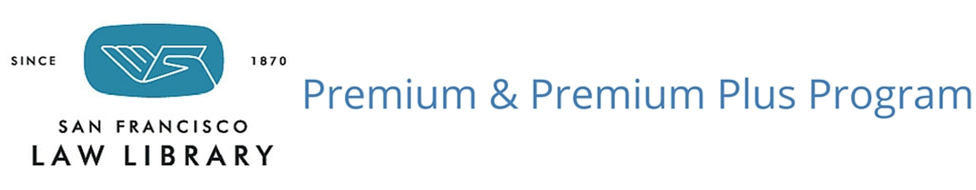

Application for San Francisco Solo & Small Firms

Premium Local for Solo & Small Firms: Firms based in San Francisco only, with 9 or fewer attorneys, may participate without fee as a service of the San Francisco Law Library, or by donation.

Larger-sized firms, or San Francisco offices that are part of a national or global firm, are welcome to join at the Premium or Premium Plus level, with a fee based on overall firm size and needs. Questions about program options available may be directed to Diane Rodriguez, Assistant Director, diane.m.rodriguez@sfgov.org or 415: 554-1793.

- FIRM NAME: __________________________________________________________________________________

- Address: _______________________________________________________________________

________________________________________________________________________________

- Number of Attorneys in SF: ______ Other Offices ______________________________________

- Library Contact or Administrator for the Firm’s Account: ________________________________________________________________________________
Phone: ___________________ Email: ________________________________________
- Other staff authorized to use the Firm’s Account:
_________________________ Phone: ________________ Email: _____________________________
_________________________ Phone: ________________ Email: _____________________________
_________________________ Phone: ________________ Email: _____________________________
_________________________ Phone: ________________ Email: _____________________________

- Let us know if you would you be interested in:

A tour of San Francisco Law Library print and electronic resources targeted to the firm’s practice areas
An overview of Lexis, Westlaw, CEB OnLaw, HeinOnline, or other Law Library subscription databases
A listing of MCLE audiotapes available for State Bar compliance
Information on participating in the Law Library Speaker Program, or other ways to support the Law Library
Making a donation to the San Francisco Law Library

