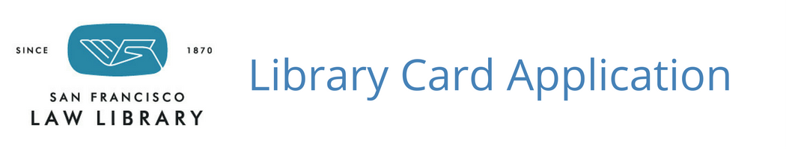

Date: ______________

Select One: Attorney State Bar Number _______________

Judge Librarian Government Other ___________

Please fill out this form as thoroughly as possible. Please return the application to:
sflawlibrary@sfgov.org or San Francisco Law Library 1145 Market Street, 4th Floor, San Francisco, CA 94103
Questions may be directed to our Information Desk: sflawlibrary@sfgov.org or 415-554-1772

- Name: ________________________________________________________________________________________

- Title: ___________________________________________________________________________

- Firm, Agency, or Department: _______________________________________________________

- Address: _______________________________________________________________________

________________________________________________________________________________

- Phone: ___________________________ Fax: _____________________________________

- Email: __________________________________________________________________________
- Proxies (legal assistants or staff members permitted to check out materials on your behalf):
_________________________ Phone: ________________ Email: _____________________________
_________________________ Phone: ________________ Email: _____________________________
_________________________ Phone: ________________ Email: _____________________________
_________________________ Phone: ________________ Email: _____________________________
- Signature: ________________________________ Date: ______________________________
- Let us know if you would you be interested in:

A tour of San Francisco Law Library print and electronic resources
An overview of Lexis, Westlaw, CEB OnLaw, HeinOnline, or other Law Library subscription databases
A listing of MCLE audio programs available for State Bar compliance
Information on participating in the Law Library Speaker Program, or other ways to support the Law Library
Making a donation to the San Francisco Law Library

Staff Use Only: Date received______________ Card issued Card sent Follow-up on programs
Borrowing Rules

Persons Who May Borrow Materials
- Members of the State Bar of California in good standing who live in San Francisco or have an office in San Francisco
- Judges of courts located in San Francisco
- Members of municipal, state, or federal agencies located in San Francisco

Loan Periods
- Most Law Library materials circulate for two weeks
- High-demand materials circulate for one week
- MCLE programs circulate for one week
- Items marked Library Use Only do not circulate

Circulation Limits per Borrowing Account
- Ten books
- Five CDs
- Five MCLE programs

Borrowing Account Information
- Patrons may request an email when checking out Library materials, listing items borrowed and due dates
- Patrons may access their accounts and renew materials online, unless they are overdue
  - Go to www.sflawlibrary.org
  - Click on Catalog
  - Click on My Library Account
  - Enter patron name and last nine digits of Library card barcode
  - If you need assistance with accessing your borrowing account, please call (415) 554-1772
- Patrons will be sent a due date reminder notice by email prior to an item’s due date

Renewal of Library Materials
- Materials may be renewed one time for one week at the end of the check-out period as long as no holds have been placed on the item
- Items seven or more days overdue may not be renewed, as the timely renewal period has already lapsed
- Items overdue less than seven days may be renewed for the remainder of the one week renewal period
- Overdue items must be renewed by phone—please call (415) 554-1772
- Once an item has been renewed, or there is a hold on an item, it must be returned to the Library by the close of business on the due date

Restriction on Checking Out Recently Returned Items
- When an item is returned, it may not be checked out again by the same borrower for 48 hours
- After 48 hours, the borrower may check the item out or call to request a hold

Overdue or Lost Materials & Fines
- Items two weeks overdue:
  - Borrowing privileges are suspended—no additional items may be borrowed, pending return of overdue Library materials
- Items one month overdue, or that are substantially damaged when returned, are deemed lost:
  - The borrower is responsible for the cost of the materials deemed lost
  - Borrowing privileges may be reinstated after payment of all applicable fees
- MCLE programs accrue overdue fines at the rate of $1 per day, including weekends and holidays

Holds
- A borrower may place a hold on an item that is currently checked out by calling the Library at (415) 554-1772
- The Library will make a reasonable effort to notify the patron when the item becomes available
- The Library will hold the item for three days from the date of notifying the patron

March 2017

